Lab 08 Ghulam Mustafa 023-22-0099

Task 01

**package** Taks1;

**import** java.util.Scanner;

**class** MyException **extends** Exception {

**void** myExc(){

System.***out***.println(**"char is an unknown operation"**);

System.***out***.println(**"Reenter, your last line:"**);

}

}

**public class** Main {

**static double** getOperation(**char** ch, **double** num, **double** result) {

**switch**(ch){

**case '+'**-> {

result+=num;

System.***out***.println(**"result "**+ch+**" "**+num+**" = "**+result);

System.***out***.println(**"updated result = "**+result);

}

**case '-'**-> {

result-=num;

System.***out***.println(**"result "**+ch+**" "**+num+**" = "**+result);

System.***out***.println(**"updated result = "**+result);

}

**case '*'**-> {

result*=num;

System.***out***.println(**"result "**+ch+**" "**+num+**" = "**+result);

System.***out***.println(**"updated result = "**+result);

}

**case '/'**-> {

result/=num;

System.***out***.println(**"result "**+ch+**" "**+num+**" = "**+result);

System.***out***.println(**"updated result = "**+result);

}

**default**-> {

**try** {

**throw new** MyException();

}**catch**(MyException e){

e.myExc();

}

}

}

**return** result;

}

**public static void** main(String[] args) {

**char** ch=**'?'**;

Scanner sc=**new** Scanner(System.***in***);

**double** result=0.0;

System.***out***.println(**"Calculator is on."**);

System.***out***.println(**"result = "**+result);

**while**(**true**) {

ch = sc.next().charAt(0);

**if**(ch==**'r'**){

System.***out***.println(**"Final result = "**+result);

System.***out***.println(**"Again? (y/n)"**);

**char** c=sc.next().charAt(0);

**if**(c==**'n'**) {

System.***out***.println(**"End Of Program"**);

System.*exit*(0);

}

**else**{

result = 0.0;

System.***out***.println(**"result = "**+result);

**continue**;

}

}

**double** num=sc.nextDouble();

result = *getOperation*(ch, num, result);

}

}

}

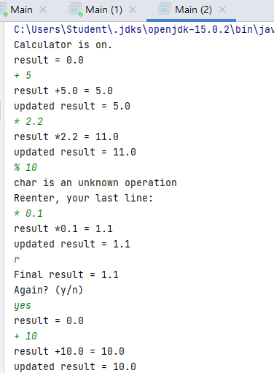

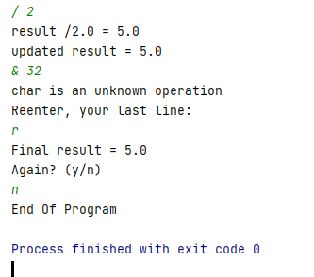

Task 02

package Task2;

import java.util.InputMismatchException;

import java.util.Scanner;

public class Main {

public static void main(String[] args) {

Scanner sc = new Scanner(System.*in*);

int n1, n2;

double r;

boolean flag = false;

while (!flag) {

try {

n1 = sc.nextInt();

n2 = sc.nextInt();

r = (double) n1 / n2;

System.*out*.println("Result: " + r);

flag = true;

} catch (InputMismatchException e) {

System.*out*.println("Invalid input!");

sc.nextLine();

} catch (ArithmeticException e) {

System.*out*.println("Will not divide by zero!");

sc.nextLine();

}

}

}

}

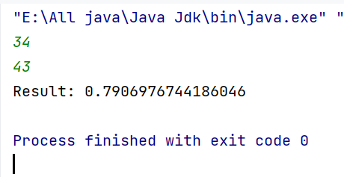

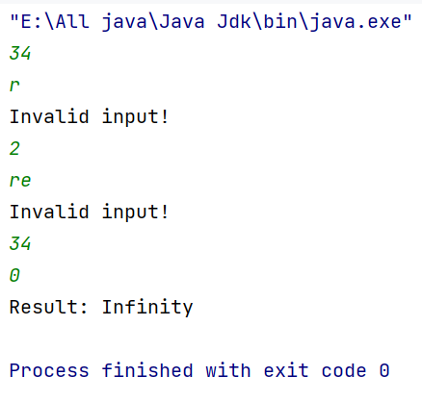

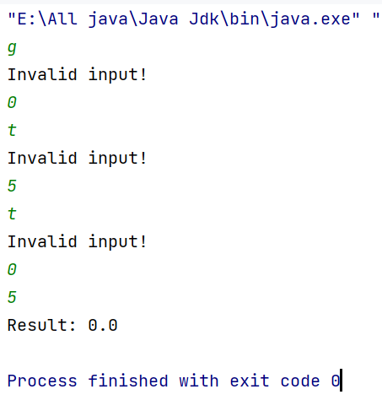

Task 03

import java.util.Scanner;

class ZeroInputException extends Exception {

public ZeroInputException() {

super("Zero input is not allowed.");

}

}

class NegativeInputException extends Exception {

public NegativeInputException() {

super("Negative input is not allowed.");

}

}

public class Task3 {

public static void main(String[] args) {

Scanner sc = new Scanner(System.*in*);

int sum = 0;

int count = 0;

try {

while (true) {

System.*out*.print("Enter a number (or 'q' to quit): ");

String input = sc.nextLine();

if (input.equalsIgnoreCase("q")) {

break;

}

try {

int number = Integer.*parseInt*(input);

if (number == 0) {

throw new ZeroInputException();

}

if (number < 0) {

throw new NegativeInputException();

}

sum += number;

count++;

} catch (NumberFormatException e) {

System.*out*.println("Invalid Number enter valid number.");

} catch (ZeroInputException e) {

System.*out*.println(e.getMessage());

} catch (NegativeInputException e) {

System.*out*.println(e.getMessage());

}

}

if (count > 0) {

double average = (double) sum / count;

System.*out*.println("Average of numbers entered: " + average);

} else {

System.*out*.println("No numbers entered.");

}

} catch (Exception e) {

System.*out*.println("Erorr404.");

}

}

}

